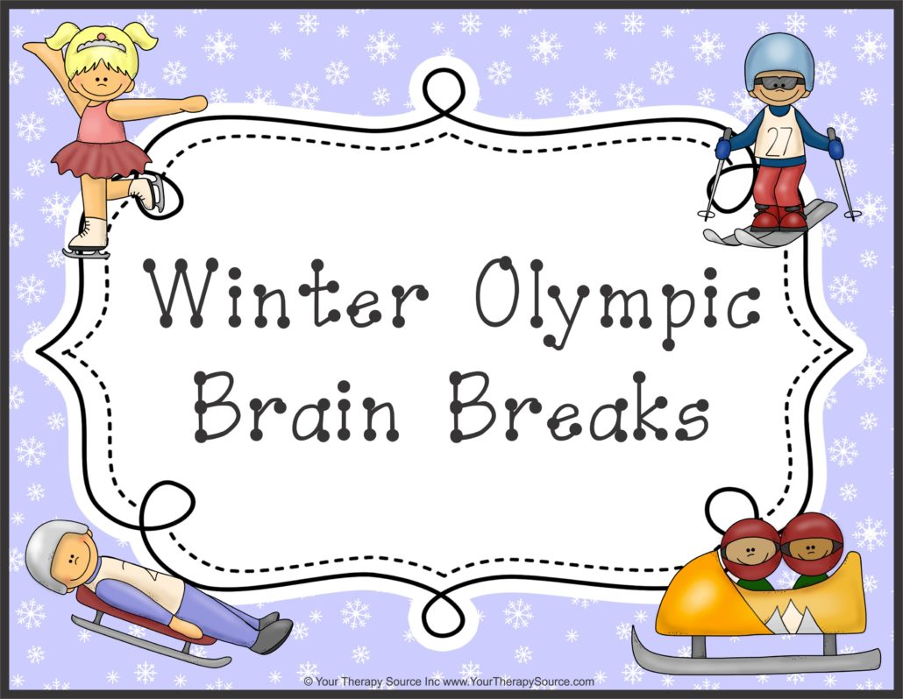

10 Winter Olympic Brain Break Ideas
The Winter Olympics are here. It’s a great time to add more movement into the classroom with brain breaks. These quick brain breaks can be highly motivating for the class during an Olympic year!
- Downhill skiing – Pretend to downhill ski. Squat down low, arms straight (reaching back and low). Keep knees together. Stand back up slowly. Pretend to glide through the snow as you squat.
- Ski Jumping – Stand up. Squat down low and count to 5 then stand up tall and go straight on your tiptoes with arms straight.
- Snowboarder – Pretend to snowboard. Stand up tall arms out to the side with feet together. Bend your knees slightly moving hips side to side.
- Slalom Skiing – Pretend to slalom ski. Stand up and keep feet together. Jump side to side in place pretending to go over the moguls and through the flags.
- Bobsledding – Sit up tall in your chair. Straighten your knees, lifting both feet up. Hold onto the sides of your chair. Lean left and right slowly like you are bobsledding down the track.
- Luge Option #1 – On the floor: Lay on the floor arms at your side. Lift both feet off the floor with knees straight and hold the position with tummy tight. Option #2 – Standing: Stand up tall, feet together with arms at side. Go up on tiptoes and balance.
- Bobsled Push – Pretend to push the bobsled to get it started. Put your hands on the wall or the desk and push. Make it harder by moving your feet further moving your feet further away from the wall.
- Curling – Curling is a sport played on ice where you need to slide stones across the ice. Bend down on one knee and push hands forward. Stand back up and bend down on the other knee.
- Figure Skating – Pretend to figure skate. Push your feet out out gracefully and twirl in place. Practice balancing on one foot.
- Ice Hockey – Pretend to move like an ice hockey player. Clasp hands together holding your stick and quickly slide feet staying in control.
adapted from yourtherapysource.com

